How To Clean Your Toilet - The Fun Way
Instructions on how to clean your toilet
1. Put both lids of the toilet up and add 1/8 cup of pet shampoo to the water in the bowl.
2. Pick up the cat and soothe him while you carry him towards the bathroom.
3. In one smooth movement, put the cat in the toilet and close both lids. You may need to stand on the lid.
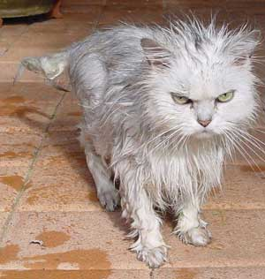
4. The cat will self agitate and make ample suds. Never mind the noises that come from the toilet, the cat is actually enjoying this.
5. Flush the toilet three or four times. This provides a "power-wash" and rinse".
6. Have someone open the front door of your home. Be sure that there are no people between the bathroom and the front door.
7. Stand behind the toilet as far as you can, and quickly lift both lids.
8. The cat will rocket out of the toilet, streak through the bathroom, and run outside where he will dry himself off.
9. Both the commode and the cat will be sparkling clean.

Scroll Down
Sincerely,
The Dog


